# Lab 11 – Introduction to LAB VIEW

## Exercise

### Question 1

**Make a task on lab view VI, to convert Fahrenheit to Kelvin.**

**Simulation:**

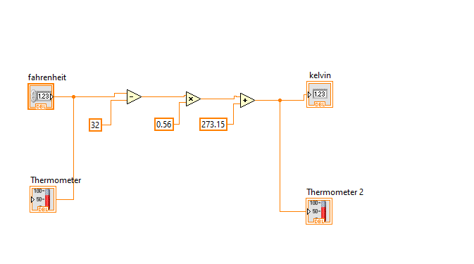

**Output:**

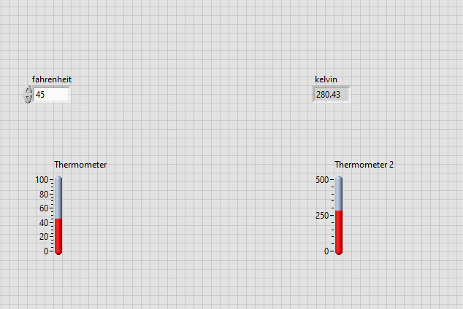

### 

### Question 2

**Make a task on lab view VI, to convert Kelvin to Degree Celsius.**

**Simulation:**

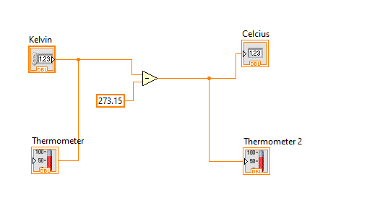

**Output:**

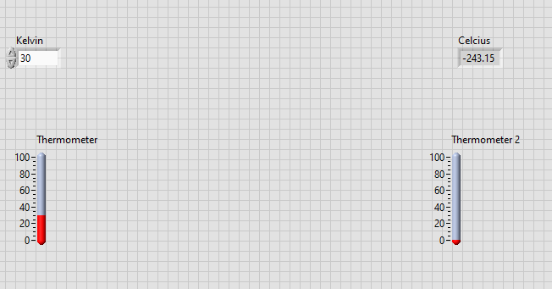

### 

### Question 3

**Make a task on lab view VI, to convert Kelvin to Fahrenheit.**

**Simulation:**

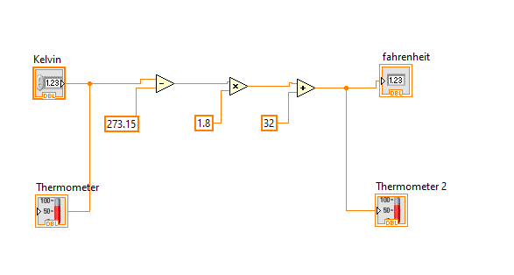

**Output:**

